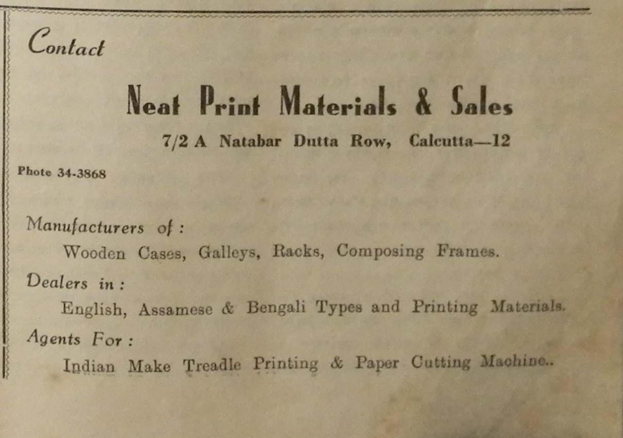

Monideep 3rd yr. 7th edition, 1963. pg537

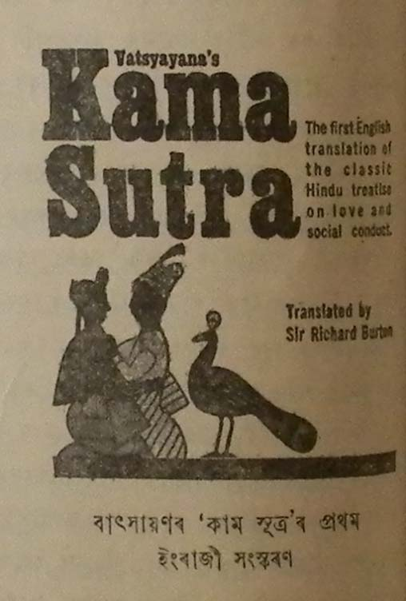

monideep, 534. 3rd yr. 7 issue. may 1963

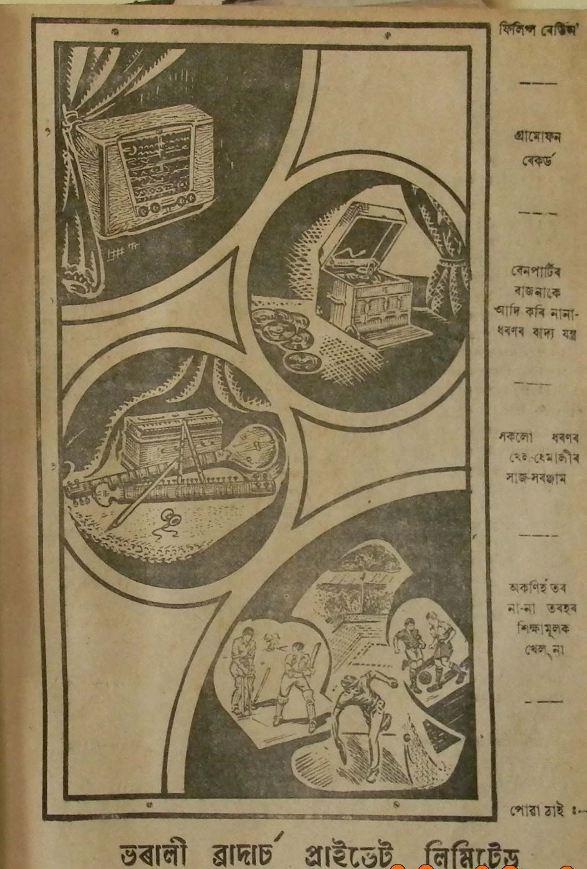

Ramdhenu 1956 (no pg no)

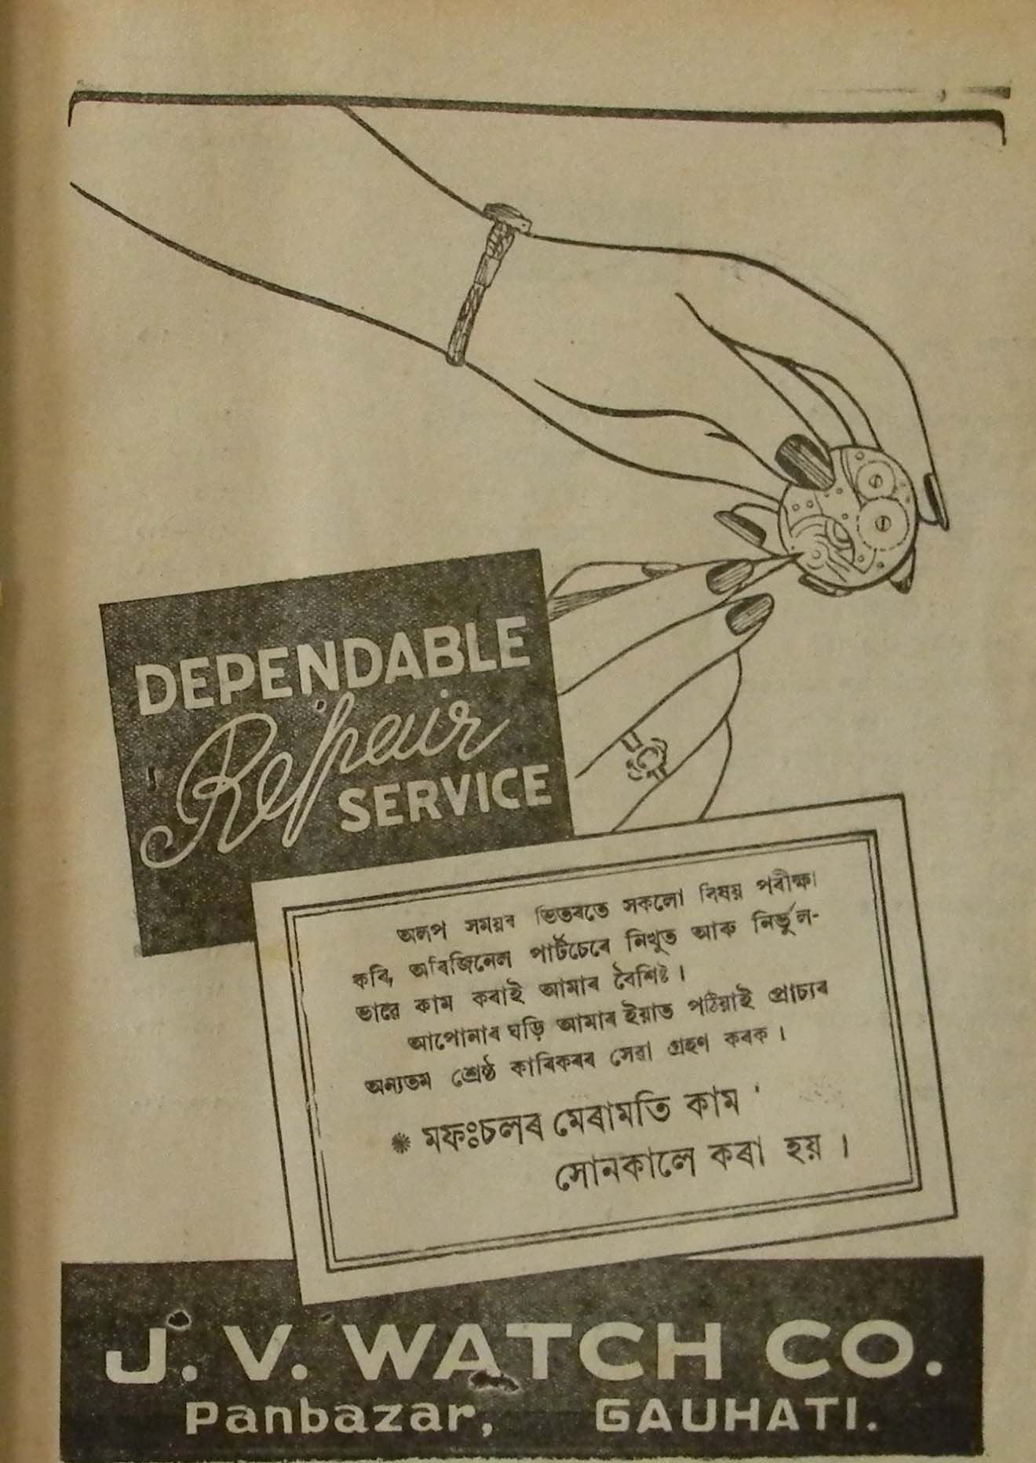

Ramdhenu 1956, twice with contents.

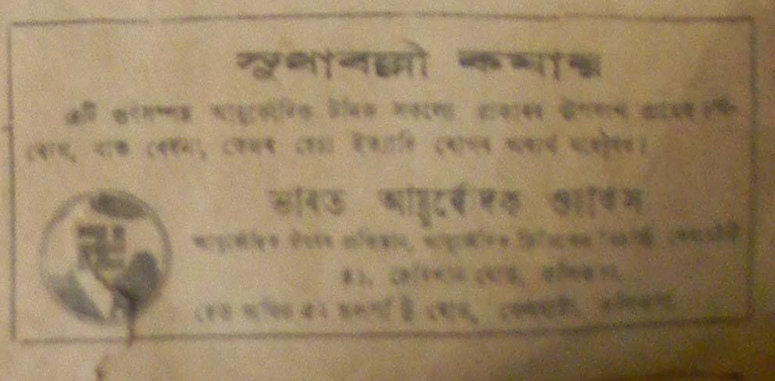

Sadinia Asomiya1945,26 fagun, pg7

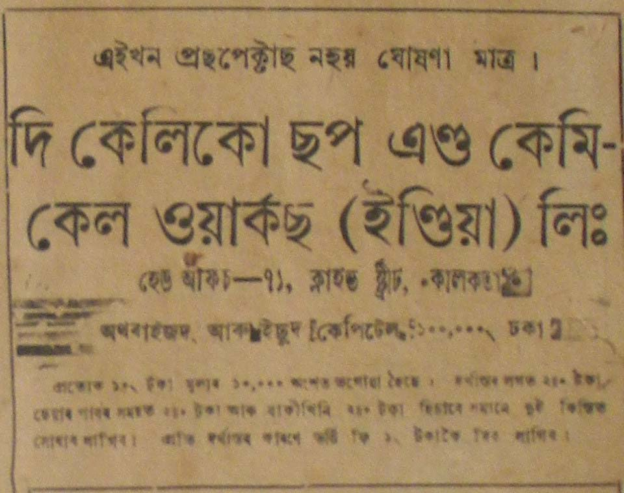

Sadinia Asomiya1945,26 fagun, pg7 c1

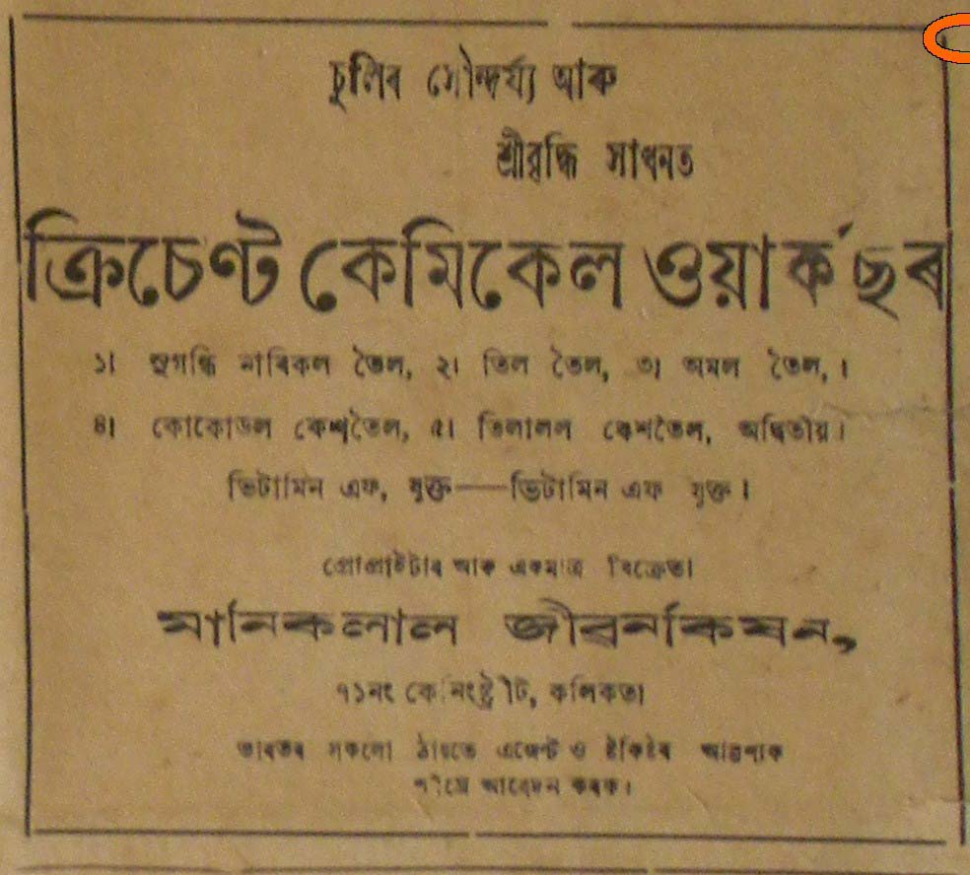

Sadinia Asomiya1945,26 fagun, pg7 c2

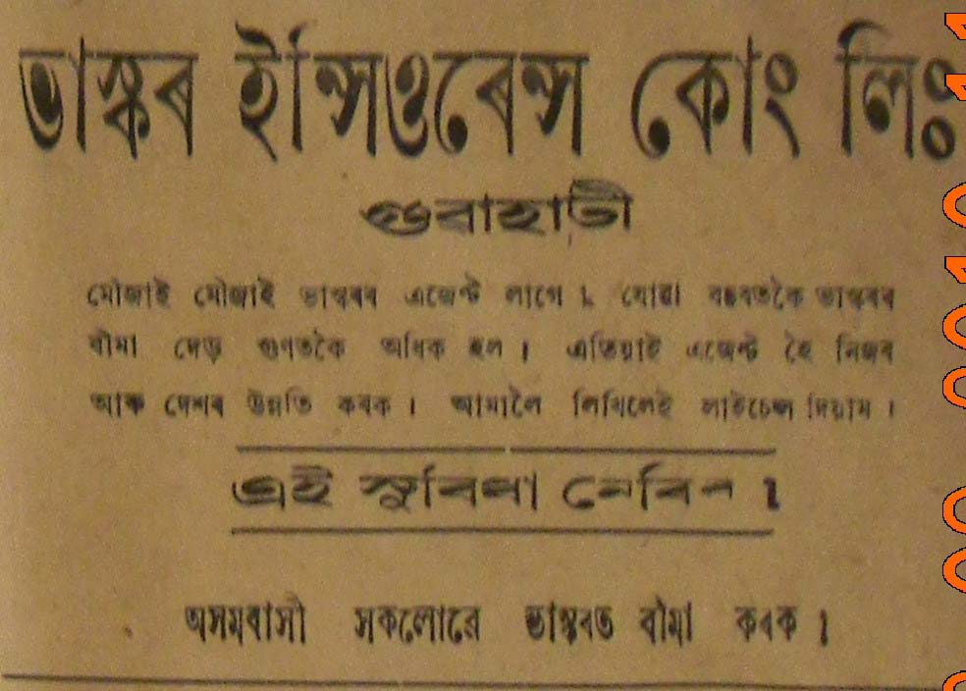

Sadinia Asomiya1945,26 fagun, pg7 c3

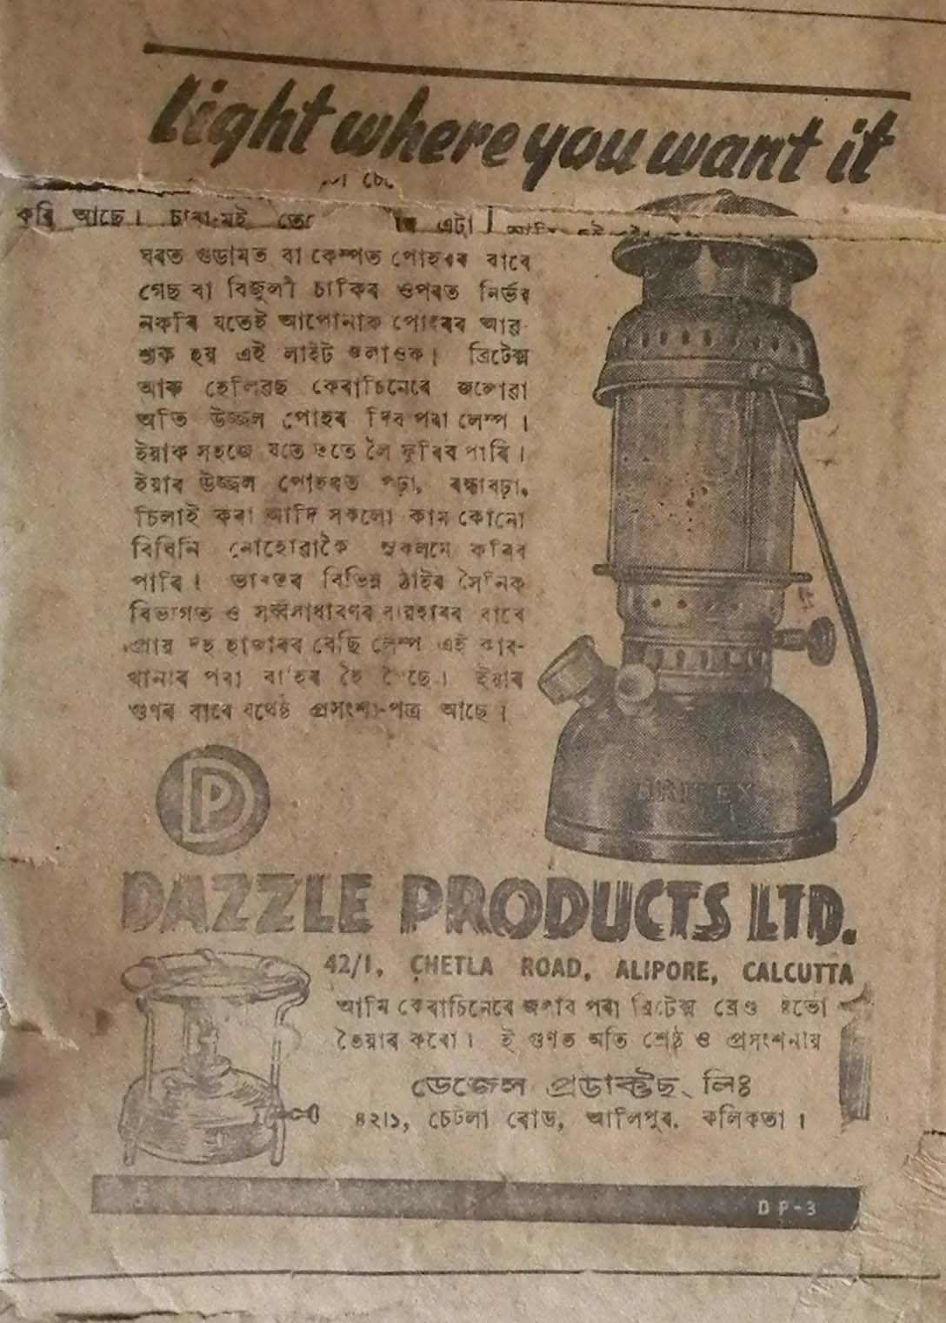

Sadinia Asomiya,3rd march. 1945, pg8

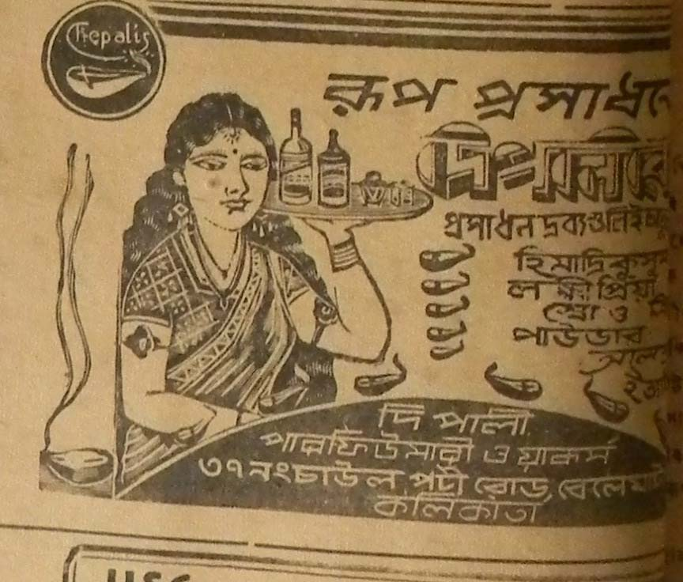

Sadinia Asomiya,10th march. 1945, pg7 c3 n Sadinia Asomiya,3rd march. 1945, pg8

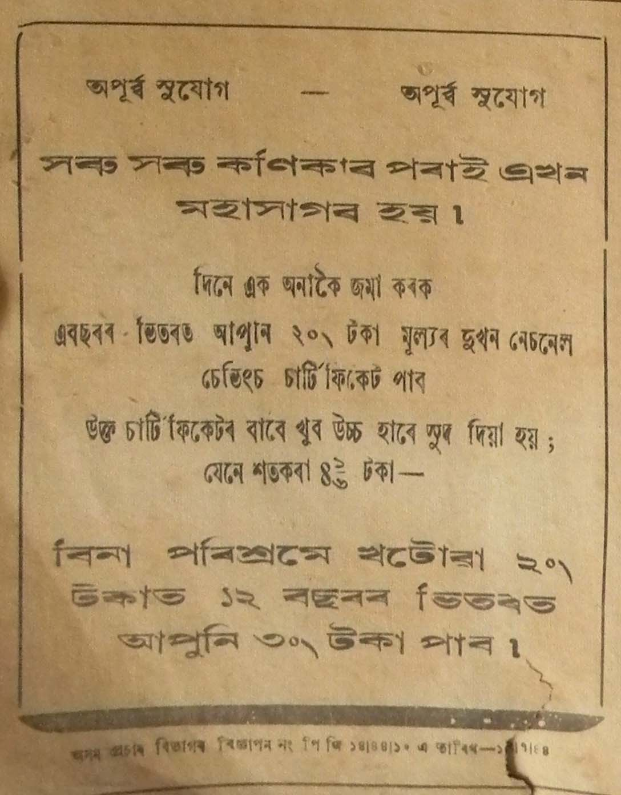

Sadinia Asomiya,10th march. 1945, pg7 copy



Sadinia Asomiya,10th march. 1945, pg7 copy1

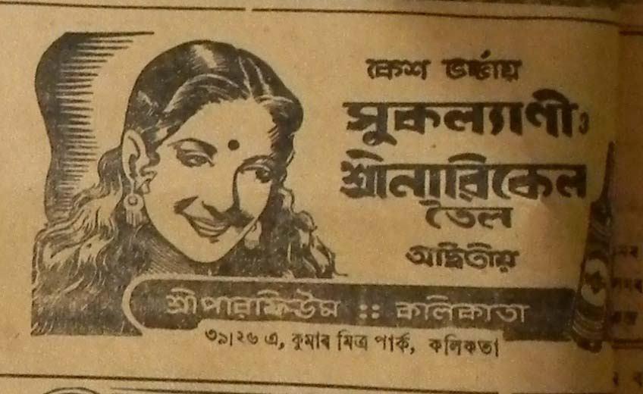

Sadinia Asomiya,10th march. 1945, pg7 n Sadinia Asomiya,3rd march. 1945, pg8

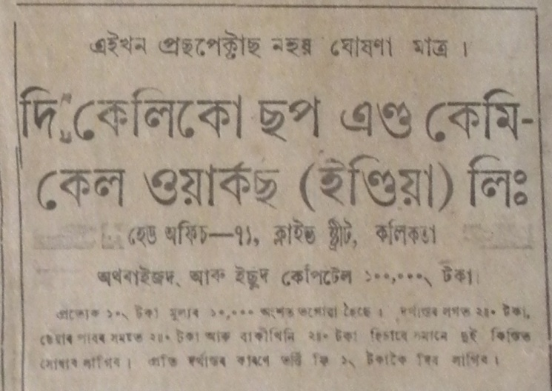

Sadinia Asomiya,19 fagun. 1945, pg7

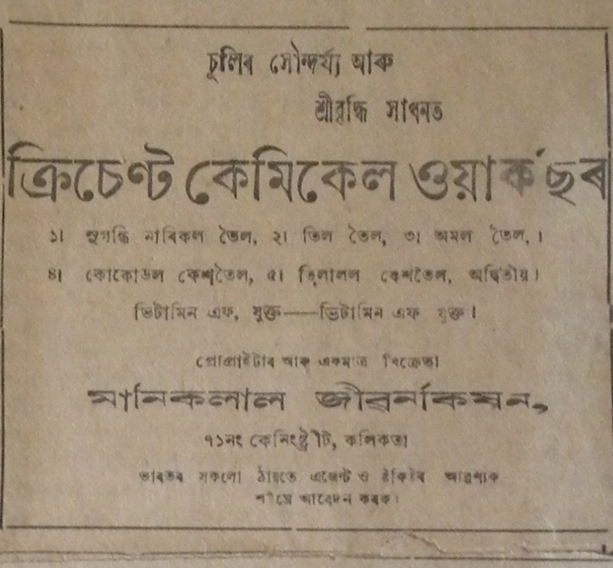

Sadinia Asomiya,19 fagun. 1945, pg7 c2

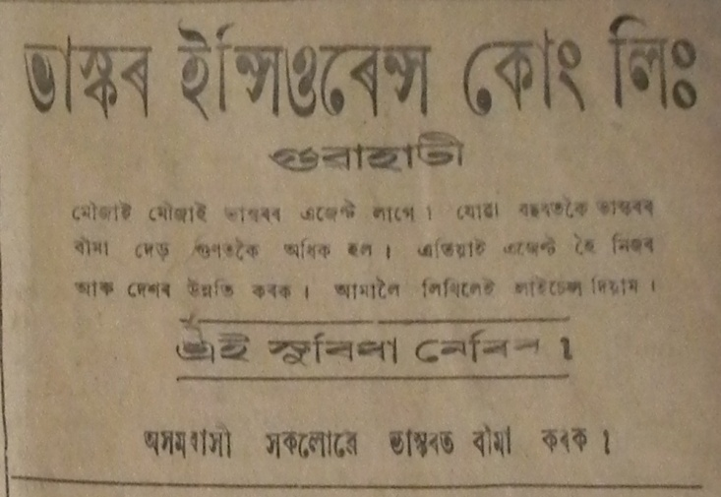

Sadinia Asomiya,19 fagun. 1945, pg7 copy1

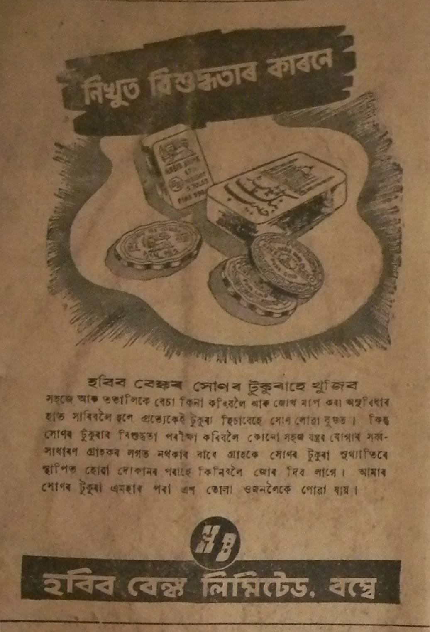

Sadiniya asomiya 1945,3rd march . pg 8 n Sadinia Asomiya,3rd march. 1945, pg8

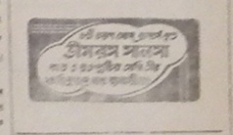

Sadiniya Asomiya,6th feb 1948, pg 4

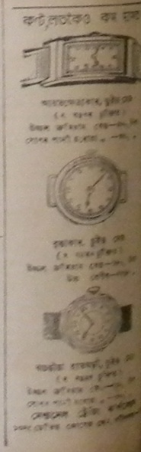

**Sadiniya Asomiya,6th feb 1948, pg 4 copy 3**

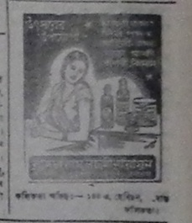

**Sadiniya Asomiya,13th aghun 1869 saka, pg 3 copy2 and Sadiniya Asomiya, 22nd nov 1947, pg5 and Sadiniya Asomiya,6th feb 1948, pg 4**

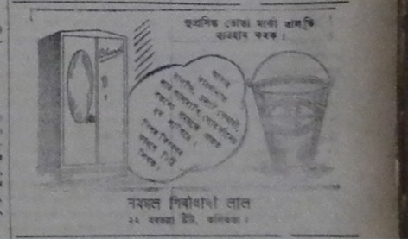

**Sadiniya Asomiya,13th aghun 1869 saka, pg 3 copy5**

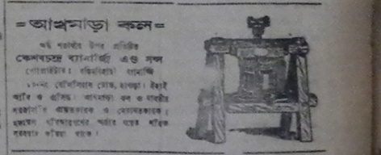

**Sadiniya Asomiya,13th aghun 1869 saka, pg 3 copy 2 and Sadiniya Asomiya, 15th nov 1947, pg4**

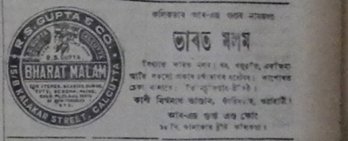

**Sadiniya Asomiya,13th aghun 1869 saka, pg 3 copy 3 and Sadiniya Asomiya, 22nd nov 1947, pg5**

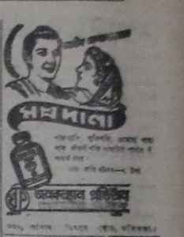

**Sadiniya Asomiya,13th aghun 1869 saka, pg 3 copy and Sadiniya Asomiya, 22nd nov 1947, pg5 and Sadiniya Asomiya, 22nd nov 1947, pg5 and Sadiniya Asomiya, 6th dec 1947, pg 3**

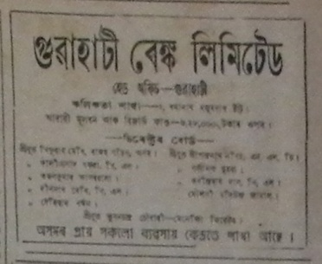

**Sadiniya Asomiya,26th april 1947 pg3**

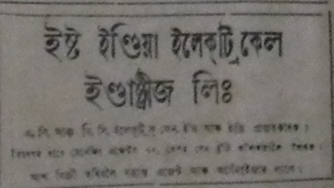

**Sadiniya Asomiya,26th april 1947 pg3 copy**

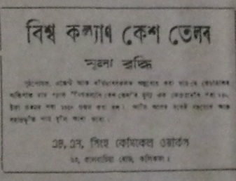

**Sadiniya Asomiya,26th april 1947 pg3 copy 2**

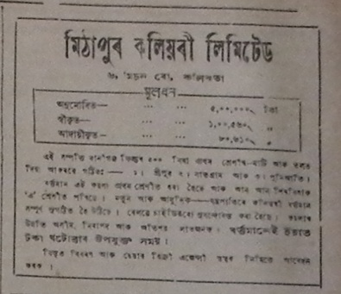

**Sadiniya Asomiya, 1st nov 1947, pg3**

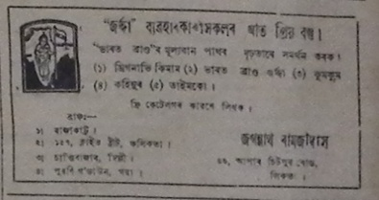

**Sadiniya Asomiya, 1st nov 1947, pg3 copy 2**

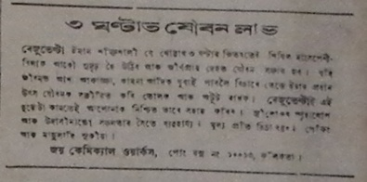

**Sadiniya Asomiya, 1st nov 1947, pg3 copy 3**

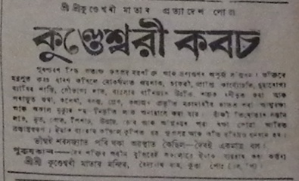

**Sadiniya Asomiya, 1st nov 1947, pg3 copy and Sadiniya Asomiya, 6th dec 1947, pg 3 n Sadiniya Asomiya, 13th September 1947, pg4**

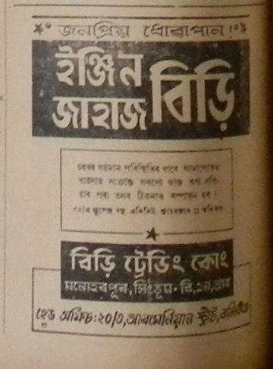

**Sadiniya Asomiya, 2nd August 1947, pg 6**

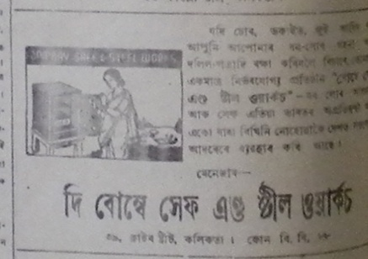

**Sadiniya Asomiya, 6th dec 1947, pg4**

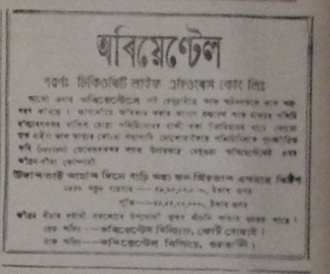

**Sadiniya Asomiya, 6th dec 1947, pg 3**



**Sadiniya Asomiya, 6th dec 1947, pg 3 copy 4**

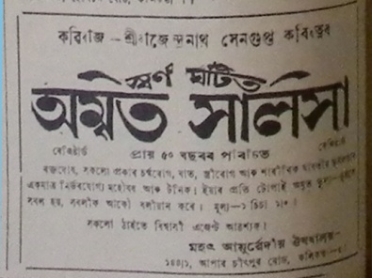

**Sadiniya Asomiya, 6th dec 1947, pg 6 and 26th nov 1947 pg 6. and Sadiniya Asomiya, 2nd August 1947, pg 3**

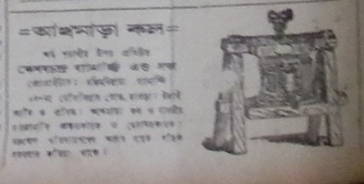

**Sadiniya Asomiya, 7th june 1947, pg 4 and Sadiniya Asomiya, 6th dec 1947, pg4**

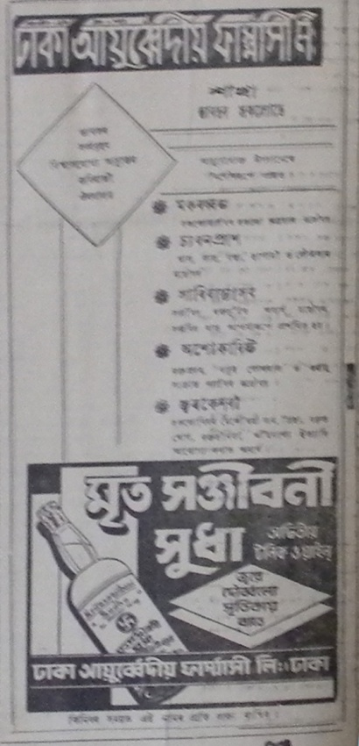

**Sadiniya Asomiya, 7th june 1947, pg 4 copy**

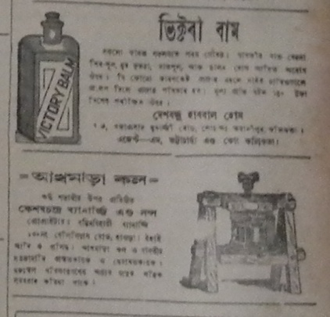

**Sadiniya Asomiya, 8th nov 1947, pg3 and Sadiniya Asomiya, 2nd August 1947, pg 3**

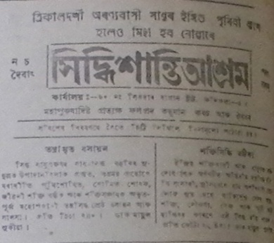

**Sadiniya Asomiya, 8th nov 1947, pg4**

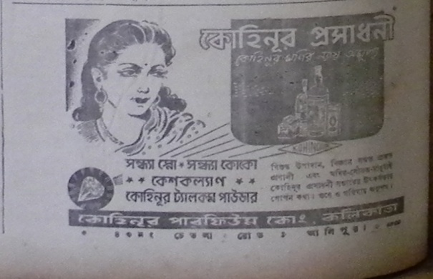

**Sadiniya Asomiya, 8th nov 1947, pg4 copy**

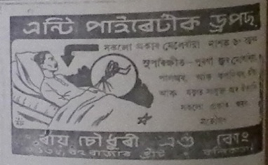

**Sadiniya Asomiya, 8th nov 1947, pg4 copy 2**

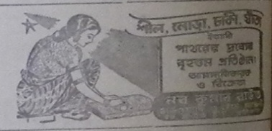

**Sadiniya Asomiya, 8th nov 1947, pg4 copy 3**

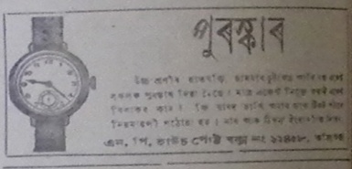

**Sadiniya Asomiya, 8th nov 1947, pg4 copy 4**

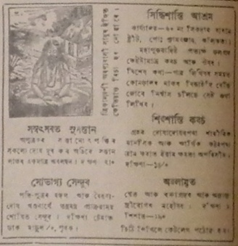

**Sadiniya Asomiya, 9th August 1947, pg 6**

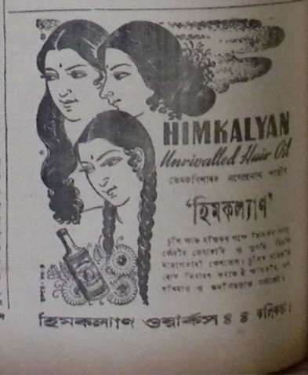

**Sadiniya Asomiya, 9th August 1947, pg 6 c1**

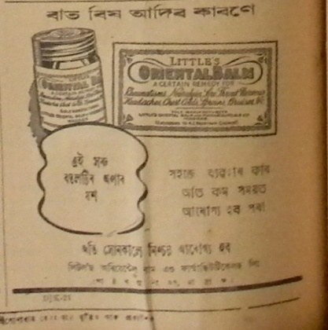

**Sadiniya Asomiya, 9th August 1947, pg 8**

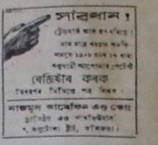

**Sadiniya Asomiya, 10th may 1947, pg 8 copy**

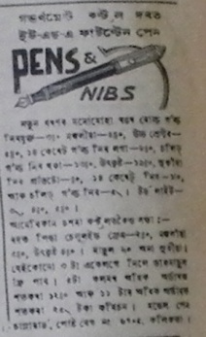

**Sadiniya Asomiya, 10th may 1947, pg 8 copy 2**

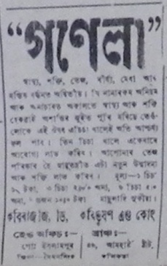

**Sadiniya Asomiya, 10th may 1947, pg 8 copy 3**

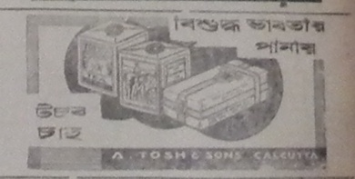

**Sadiniya Asomiya, 11 magh, 1869 saka, pg 3 and Sadinia Asomiya,3rd march. 1945, pg8 and Sadinia Asomiya,10th march. 1945, pg7**

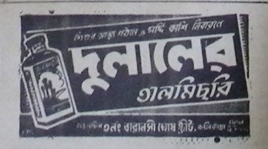

**Sadiniya Asomiya, 11 magh, 1869 saka, pg 3 copy and Sadiniya Asomiya,26th april 1947 pg3 and Sadiniya Asomiya, 6th dec 1947, pg 3**

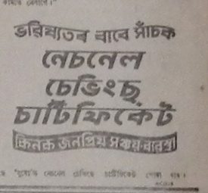

**Sadiniya Asomiya, 11 magh, 1869 saka, pg 3copy2 and 10th january 1948 pg 5**

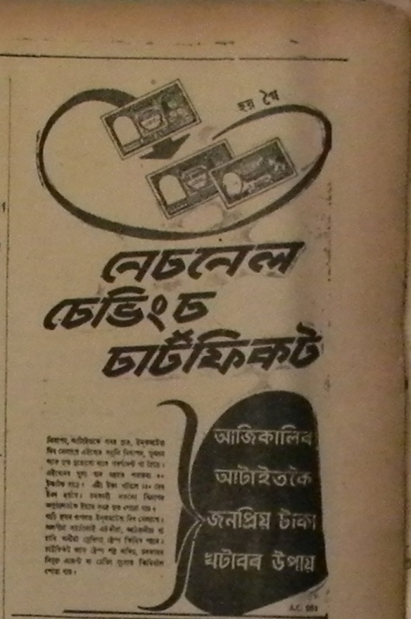

**Sadiniya Asomiya, 12th july 1947, pg 3**

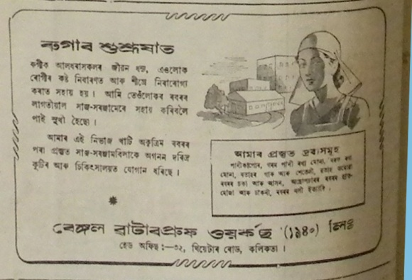

**Sadiniya Asomiya, 13th march, 1948. pg6**

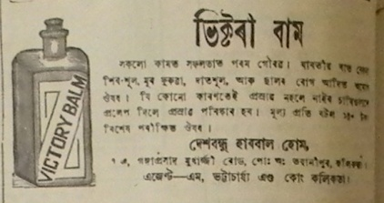

**Sadiniya Asomiya, 13th march, 1948. pg6 c1 and Sadiniya Asomiya, 13th march, 1948. pg6 c2 n Sadiniya Asomiya, 9th August 1947, pg 6**

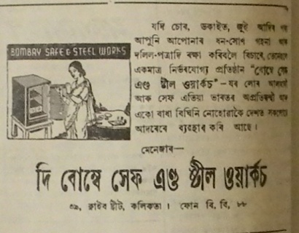

**Sadiniya Asomiya, 13th march, 1948. pg6 c3**

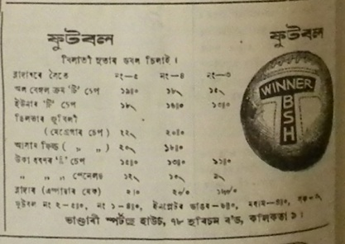

**Sadiniya Asomiya, 13th march, 1948. pg6 c4**

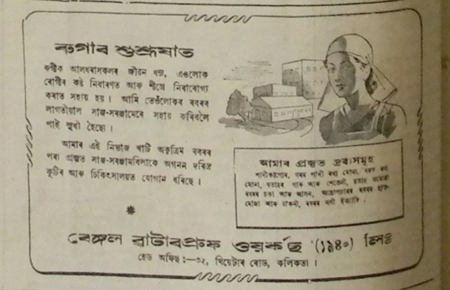

**Sadiniya Asomiya, 13th march, 1948. pg6 c5**

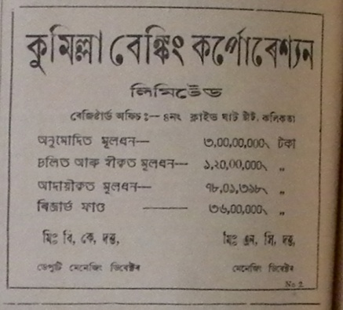

**Sadiniya Asomiya, 13th September 1947, pg4**

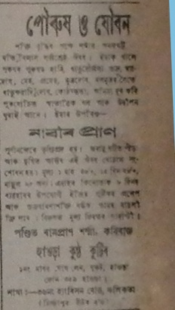

**Sadiniya Asomiya, 15th nov 1947, pg5 copy4**

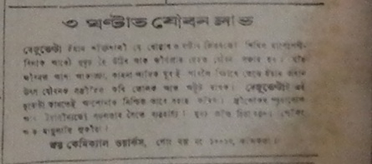

**Sadiniya Asomiya, 15th nov 1947, pg5 copy8**

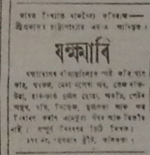

**Sadiniya Asomiya, 15th nov 1947, pg5 copy 2**

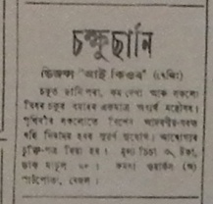

**Sadiniya Asomiya, 15th nov 1947, pg5 copy 3**

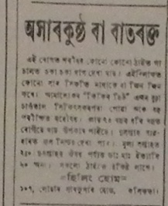

**Sadiniya Asomiya, 15th nov 1947, pg5 copy 4**

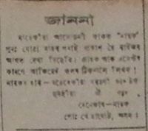

**Sadiniya Asomiya, 15th nov 1947, pg5 copy 5**

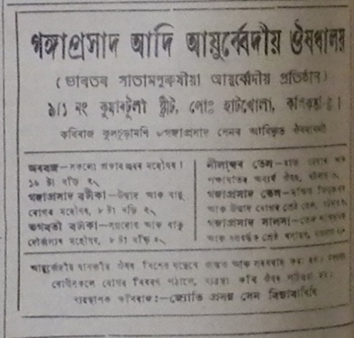

**Sadiniya Asomiya, 22nd nov 1947, pg4 copy**

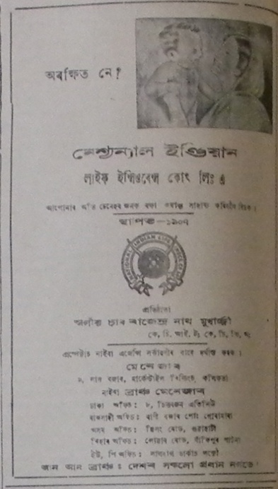

**Sadiniya Asomiya, 22nd nov 1947, pg4 copy 2**

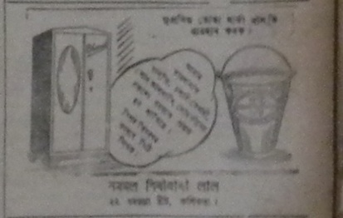

**Sadiniya Asomiya, 22nd nov 1947, pg5 and Sadiniya Asomiya, 6th dec 1947, pg4**

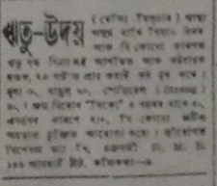

**Sadiniya Asomiya, 22nd nov 1947, pg5 copy7**

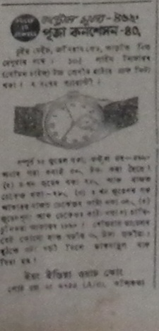

**Sadiniya Asomiya, 22nd nov 1947, pg5 copy 2 and Sadiniya Asomiya, 23rd August 1947, pg 8**



**Sadiniya Asomiya, 22nd nov 1947, pg5 copy 3**

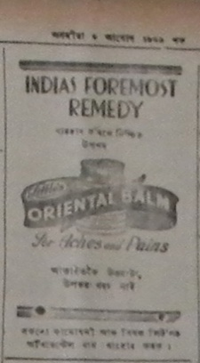

**Sadiniya Asomiya, 22nd nov 1947, pg5 copy 4**

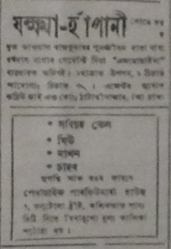

**Sadiniya Asomiya, 22nd nov 1947, pg5 copy 6**

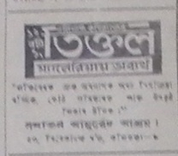

**Sadiniya Asomiya, 23rd August 1947, pg2**

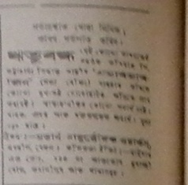

**Sadiniya Asomiya, 23rd August 1947, pg2 c2**

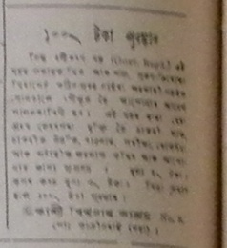

**Sadiniya Asomiya, 23rd August 1947, pg2 c6**

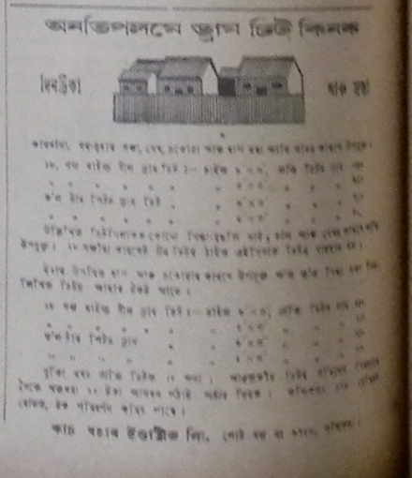

**Sadiniya Asomiya, 23rd August 1947, pg2 copy**

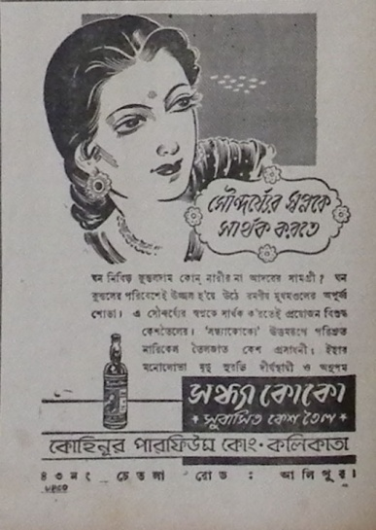

**Sadiniya Asomiya, 23rd August 1947, pg 2**

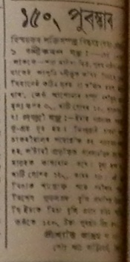

**Sadiniya Asomiya, 23rd August 1947, pg 8 c3**

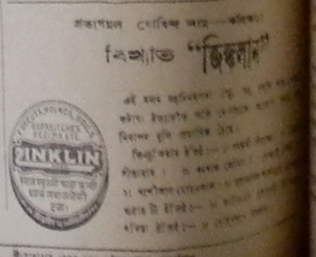

**Sadiniya Asomiya, 23rd August 1947, pg 8 c5**

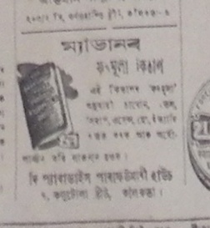

**Sadiniya Asomiya, 23rd August 1947, pg 8 c7**

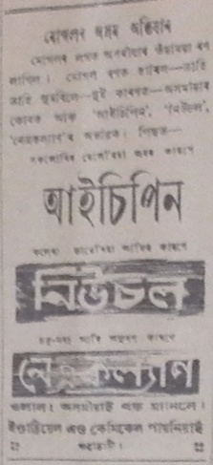

**Sadiniya Asomiya, 23rd August 1947, pg 8 copy 2**

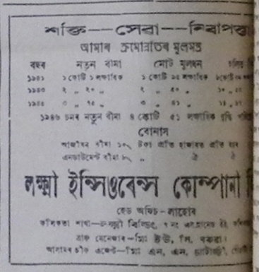

**Sadiniya Asomiya, 24th may 1947, pg 2**

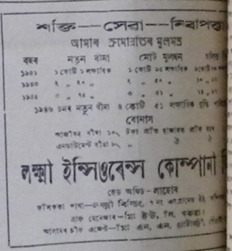

**Sadiniya Asomiya, 24th may 1947, pg 2 copy**

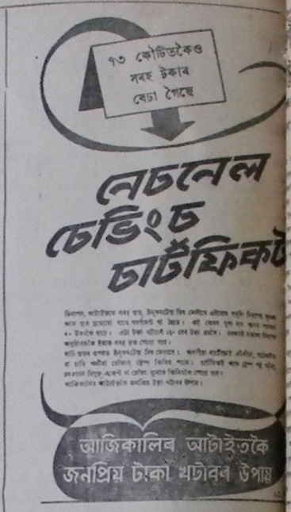

**Sadiniya Asomiya, 24th may 1947, pg 2 copy 2 and Sadiniya Asomiya, 24th may 1947, pg 2**

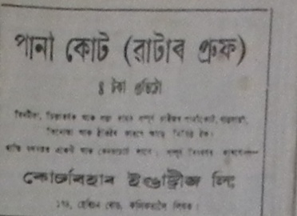

**Sadiniya Asomiya, 24th may 1947, pg 3**

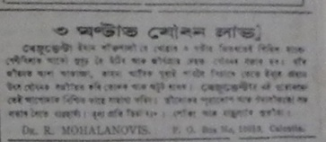

**Sadiniya Asomiya, 24th may 1947, pg 3 copy 2**

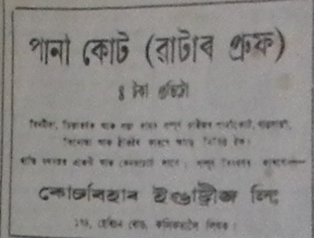

**Sadiniya Asomiya, 24th may 1947, pg 3 copy 3**

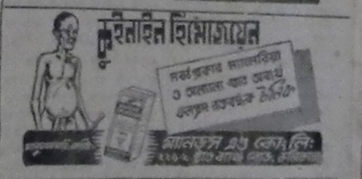

**Sadiniya Asomiya, 24th may 1947, pg 3 copy 4 and Sadiniya Asomiya, 31st may 1947, pg 6**

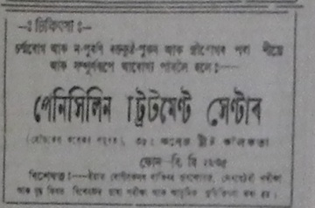

**Sadiniya Asomiya, 24th may 1947, pg 3 copy 5 and Sadiniya Asomiya, 31st may 1947, pg 6**

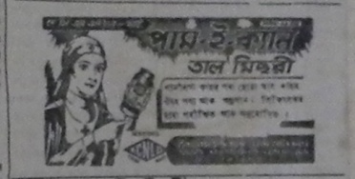

**Sadiniya Asomiya, 24th may 1947, pg 3 copy and Sadiniya Asomiya, 2nd August 1947, pg 6 and Sadiniya Asomiya, 31st may 1947, pg 6 and Sadiniya Asomiya, 26th july 1947, p3**

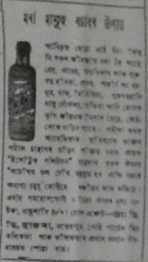

**Sadiniya Asomiya, 24th may 1947, pg 7**

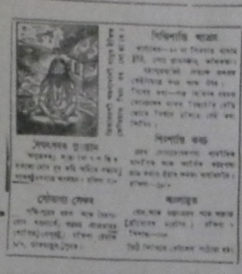

**Sadiniya Asomiya, 24th may 1947, pg 7 copy**

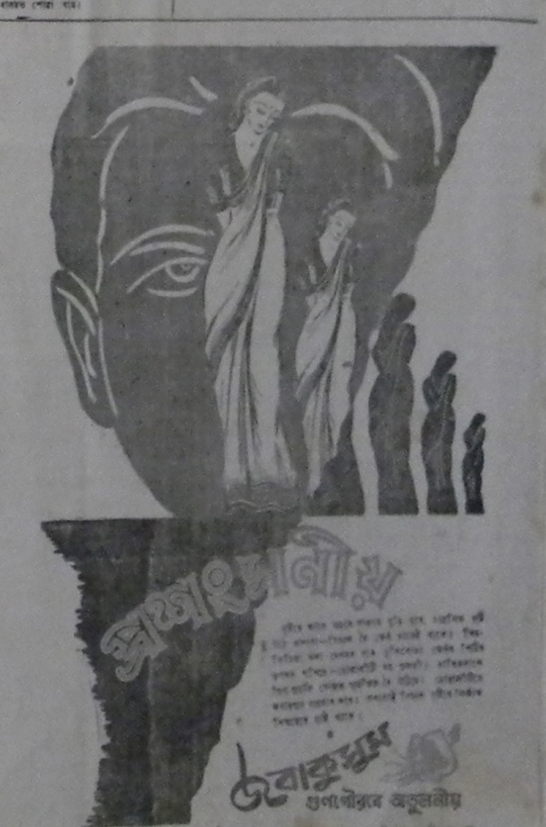

**Sadiniya Asomiya, 24th may 1947, pg 7 copy 3**

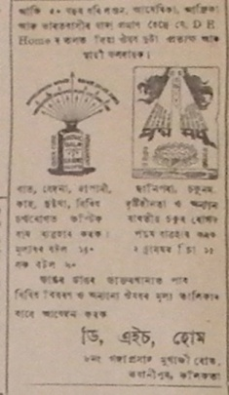

**Sadiniya Asomiya, 26th july 1947, pg 4 and Sadiniya Asomiya,6th feb 1948, pg 4 copy 4**

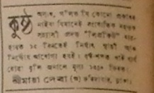

**Sadiniya Asomiya, 26th july 1947, pg 4 c0**

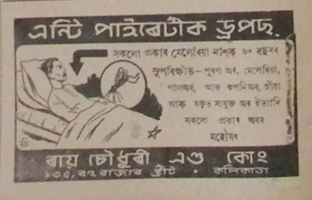

**Sadiniya Asomiya, 26th july 1947, pg 4 c2 and Sadiniya Asomiya, 6th dec 1947, pg4**

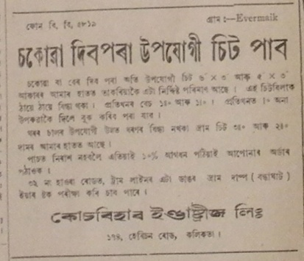

**Sadiniya Asomiya, 26th july 1947, pg 4 c6**

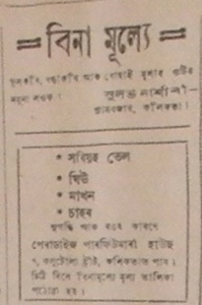

**Sadiniya Asomiya, 26th july 1947, pg 4 c8**

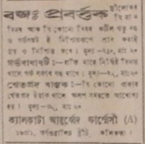

**Sadiniya Asomiya, 26th july 1947, pg 4 copy**

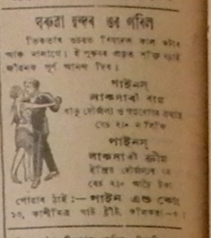

**Sadiniya Asomiya, 26th july 1947, pg 4 copy4 and Sadiniya Asomiya, 23rd August 1947, pg 5**

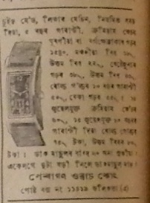

**Sadiniya Asomiya, 26th july 1947, pg 4 copy5**

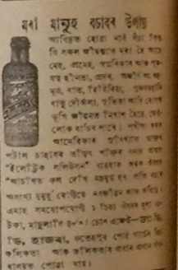

**Sadiniya Asomiya, 26th july 1947, pg 4 copy6 and Sadiniya Asomiya, 23rd August 1947, pg 8**

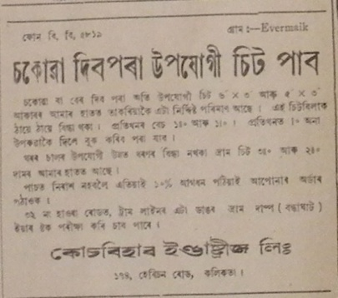

**Sadiniya Asomiya, 26th july 1947, pg 4 copy9**

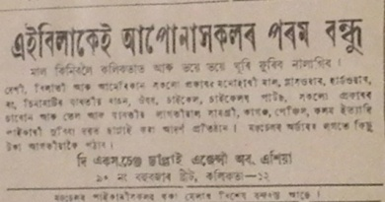

**Sadiniya Asomiya, 26th july 1947, pg 4 copy 8**

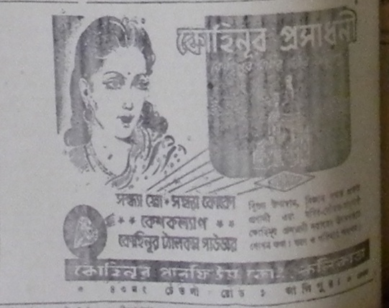

**Sadiniya Asomiya, 26th nov 1947 pg 6.**

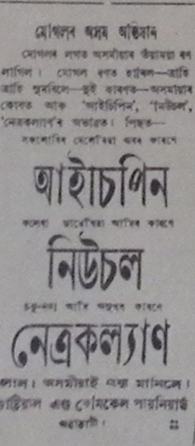

**Sadiniya Asomiya, 27th September 1947, pg8**

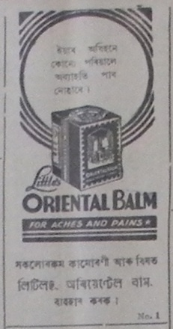

**Sadiniya Asomiya, 27th September 1947, pg8 c2**

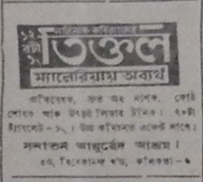

**Sadiniya Asomiya, 27th September 1947, pg8 c5**

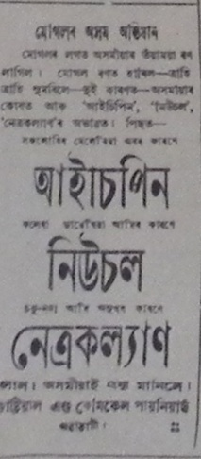

**Sadiniya Asomiya, 27th September 1947, pg8 copy5**

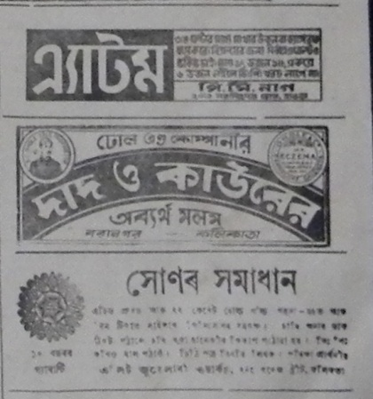

**Sadiniya Asomiya, 28th feb , 1948. pg3**

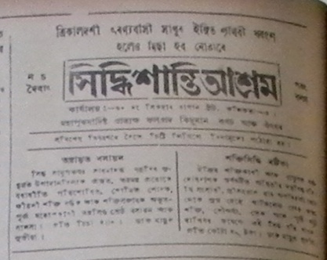

**Sadiniya Asomiya, 30th August 1947, pg2**

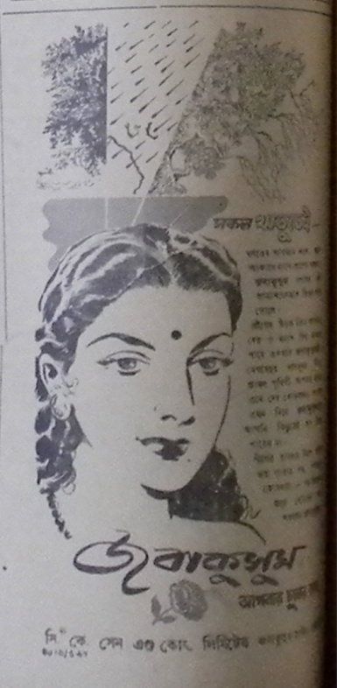

**Sadiniya Asomiya, 30th August 1947, pg2 copy**

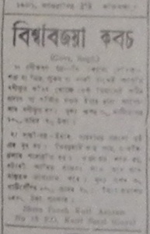

**Sadiniya Asomiya, 30th August 1947, pg 3**

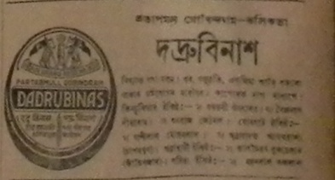

**Sadiniya Asomiya, 30th August 1947, pg 3 and Sadiniya Asomiya, 2nd August 1947, pg 3fgtrrr**

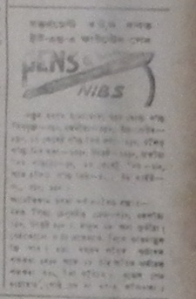

**Sadiniya Asomiya, 30th August 1947, pg 3 copy 2**

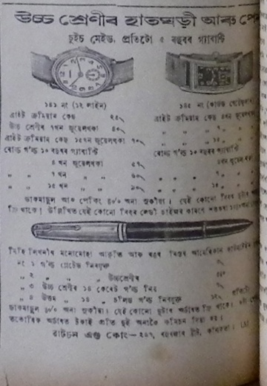

**Sadiniya Asomiya, 31st may 1947, pg 6**

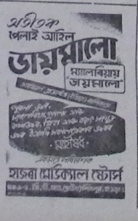

**Sadiniya Asomiya, 31st may 1947, pg 6 c5**

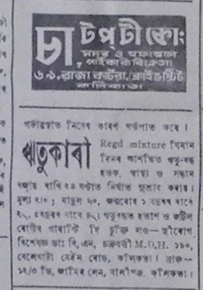

**Sadiniya Asomiya, 31st may 1947, pg 6 c6**

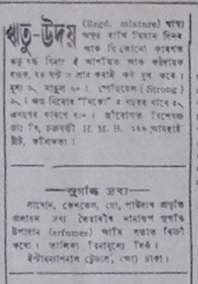

**Sadiniya Asomiya, 31st may 1947, pg 6 c8**

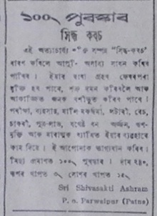

**Sadiniya Asomiya, 31st may 1947, pg 6 copy**

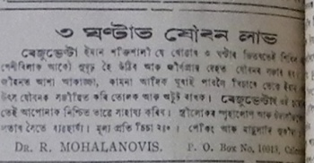

**Sadiniya Asomiya, 31st may 1947, pg 6 copy 2**

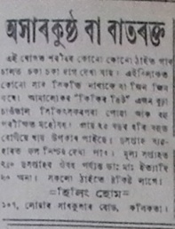

**Sadiniya Asomiya, 31st may 1947, pg 6 copy 3**

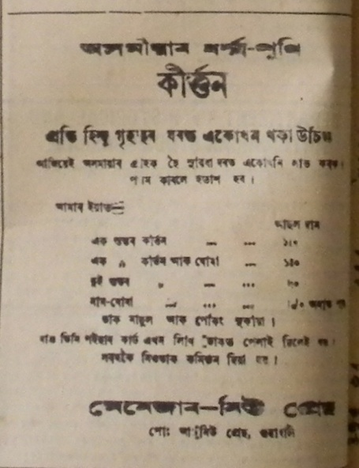

**tinidiniya asomiy a27 april 1934 pg 8 c1**

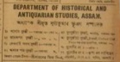

**Tinidiniya Asomiya.6 march 1934, pg 7 and 13th march 1934 pg 8 and 3rd april pg7**

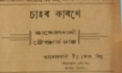

**Tinidiniya Asomiya.6 march 1934, pg 7 copy**

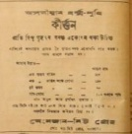

**Tinidiniya Asomiya.6 march 1934, pg 8 and 6 and 13th march 1934 pg 8**

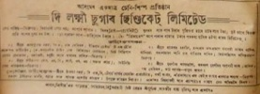

**Tinidiniya Asomiya.9 march 1934, pg 8**

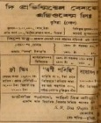

**Tinidiniya Asomiya.13 march 1934, pg 8**

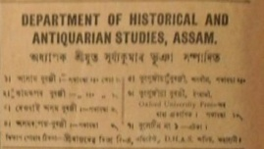

**Tinidiniya Asomiya.18 puh, 1855 saka, pg 7**

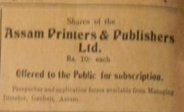

**Tinidiniya Asomiya.18 puh, 1855 saka, pg 7 copy**

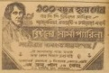

**Tinidiniya Asomiya.27 feb, 1934, pg6 and 8 and 16 march 1934, pg 8**

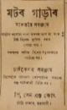

**Tinidiniya Asomiya.1934. 23 march pg 6 and 3rd april pg7**

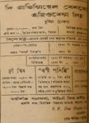

**Tinidiniya Asomiya.1934. 30 march pg 8**

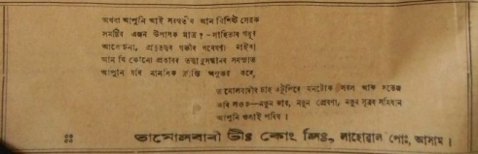

**Tinidiniya Asomiya. 2nd january, 1934, pg6**

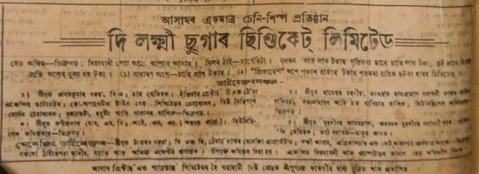

**Tinidiniya Asomiya. 2nd january, 1934, pg8**

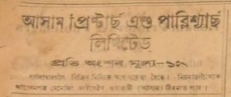

**Tinidiniya Asomiya. 2nd january, 1934, pg8 copy1**

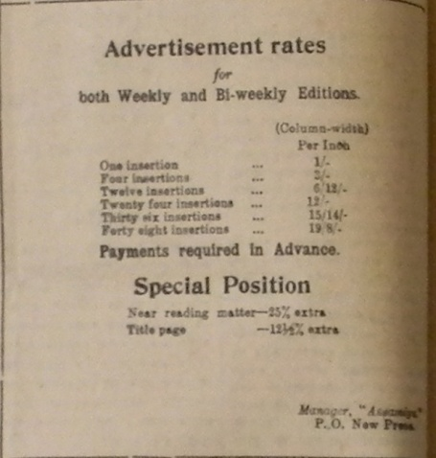

**TinidiniyaAsomiya PartII. 27 april, 1934, pg8**